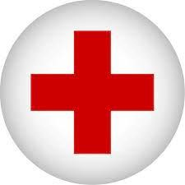
American Red Cross
Scholarship
Cerro Gordo High School has collected 44 units of blood this year 24-25, qualifying us for a $500 scholarship. Please fill out the following: Due Date: April 17, 2026
Name:______________________________________________________

How many times have you tried donating blood in school _____ out of school _____?
How many units of blood have you successfully donated thus far_____?

Essay:
1 Full Page
12 point
Times New Roman
Prompt: Why is it important for you and others to donate blood? Please give factual and personal evidence.

Due Date: April 17, 2026 to Mr. Vogel.
